# PROJECT REPORT

INTRODUCTION;

OVER VIEW

**EMPATHY MAP [GLOBAL WARMING],BRAINSTROMING[GLOBAL WARMING] AND DESIGN A LOGO WITH CANVA[INVITATION FOR GLOBAL WARMING AWARNESS].**

**PURPOSE**

TO Protect our life Global warming causes climate change, which poses a serious threat to life on Earth in the forms of widespread flooding and extreme weather.future. problem definition and design thinking;

Empathy map[Global warming]

Brainstroming map[Global warming]

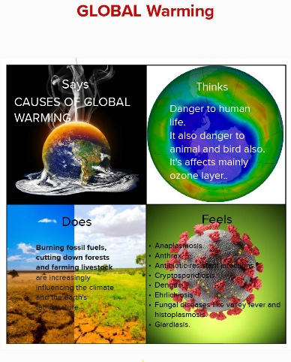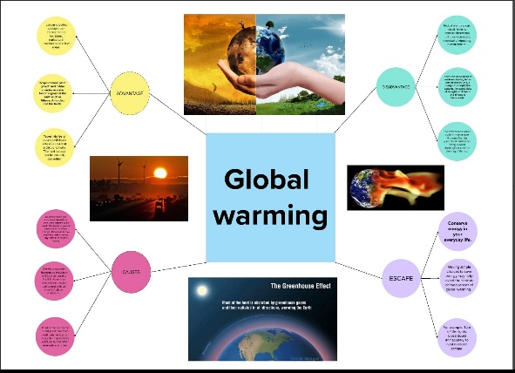

# RESULT; Design a logo with canva [Gobal warming]

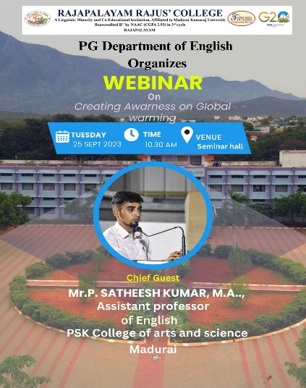

# ADVANDAGE AND DISADVANDAGE;

This designs are used for Awareness to Global warming and our future life that is the advan

tages of my design.

Some body aware my design or ignore my design and that matter was sayed many

peoples but no one take about that matter. That is my design dis advantage.

# APPLICATION;

My team design only use for awarness from Global warming and do not use organic fiertilizer it causes

decrease soil quality and that foods like slow poition it affect our life,it causes many disease like skin problem and

cancer and etc.....,

# CONCLUSION

I learn many things about this naan mudhalvan project,i learn how to use to edit in mural app and canva app

that shceme is very useful to all. we are learn many things from it thank you! for this shceme by our CM M.K.Stalin.